

IP Address and Subnet Capacity Report

**2016 – Q2**

Bruce Kusko, Sr. Technology Architect

Cerner Corporation

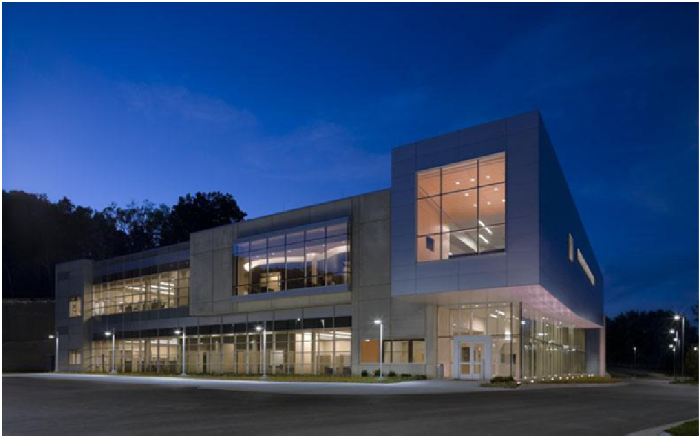

**Cerner Technology Services**

Contents

Overview 3

Executive Summary 4

Background 6

IP Addresses 6

IP Subnets 6

Scope 7

Definitions 7

Report Details 8

1. How Much Public IP Address Capacity Does Cerner Have? 8

IP Addresses 8

IP Subnets 9

2. How Much IP Address Capacity is Used/Available? 10

IP Addresses 10

IP Subnets 11

3. How Fast is Cerner Consuming IP Capacity? 12

IP Addresses 12

IP Subnets 13

4. When Will Cerner Run Out of IP Capacity? – Forecasts 14

IP Addresses 14

IP Subnets 16

Summary 18

APPENDICES 20

APPENDIX 1 - Why only Bluecat Proteus? 20

APPENDIX 2 - Data Wrangling Bluecat Proteus IP data 21

APPENDIX 3 - ARIN Counting 23

APPENDIX 4 – Bluecat Proteus Data – Merged CWx and CES 24

This report can be found on the CTS Capacity Management uCern site: <https://connect.ucern.com/groups/cts-capacity-management>

# Overview

The goal of this quarterly report is to present the state of our public IP capacity, both IP addresses and IP subnets. They are finite resources and need to be allocated judiciously. One of the main findings is the “run-out” date, or when we will no longer be able to give IP resources to new clients. As running out is unacceptable, newer reports have added the 90% and 80% dates, to give us a timeframe for action.

Our immediate shortage of public IP subnets has been mitigated, at least in principle, as Cerner approached, and has been pre-approved by ARIN to purchase a class B public IP address range with 65,536 IP addresses. These IP addresses are expected to be available within 2 – 3 months. Our longer term public IP capacity issues still need to be addressed, as the new subnet range will most likely be consumed within 3 years.

As quarterly updates are not often enough to keep up with how well we are following subnet allocation protocols, these IP address and subnet capacity reports will now be presented on the CTS Capacity Management uCern site: <https://connect.ucern.com/groups/cts-capacity-management> uCern site, and updated monthly, soon to be weekly.

Data in these reports comes from Bluecat Address Manager, aka Proteus. The reason for using a single data source is explained in Appendix 1. Data quality is an ongoing problem with IP data, and the CTS Capacity Management team is working on an IP Data Warehouse (IPDW) that is merging data from Bluecat Proteus as well as Remedy and DNS. It is the hope that multiple datasets can be used to compute a “gold set: of IP address and subnet data. Much work remains to be done in this area.

Data in this report can be interpreted as “we have plenty of IP addresses left – we’re only using 37% of what we have” (aka Finance view) or “we have no more IPs available to create new subnets” (aka Network Architect view.) Unfortunately, the true view is closer the latter.

For this reason, Cerner has petitioned and been approved by the American Registry of Internet Numbers (ARIN) to purchase an additional class B IP address range (with 65,000 IP addresses.) Although ARIN is officially out of IPv4 addresses, there are still a number of these class B ranges available from Universities and other third-party sources. Costs are estimated to be around $500,000.

# Executive Summary

* The critical IP resources are subnets, and we are running out of available space to create new subnets. Yet we don’t have a good handle on our subnet capacity.
* Cerner has been pre-approved by ARIN to purchase a class B public IP address range with 65,536 IP addresses. These IP addresses are expected to be available within 2 – 3 months. The immediate crisis of “running out of IP capacity” has been mitigated, at least for a couple of years.
* IP capacity data from Cerner Health Services (CHS) has been added to this report. This data, however, are kept separate as CHS IP addresses cannot currently be used by CWx or CES clients. On the other hand, CWx IP addresses may soon be used by CHS clients as these clients are moved from Soarian to Millennium.
* Unfortunately, the data quality of our IP capacity is poor, so the uncertainties are significant. There are multiple overlapping, inconsistent, missing, and manually updated data sources showing our IP capacity… Proteus, Remedy, DNS, ADDM. The data presented must be qualified with an uncertainly range of at least +/- 5%.

CTS Capacity Management provides answers the following questions.

1. What is our public IP address and subnet capacity?
2. How much is used and how much is available?
3. How fast are we consuming IP capacity?
4. When will we run out?

Only the first question is easy to answer. The other three are more difficult to answer, especially considering that CTS does not have an IP Address Management Tool. A variety of answers are shown in the following table. The variety of answers are explained in this report.

|  |  |  |  |  |
| --- | --- | --- | --- | --- |
| IP Capacity and  Consumption | CWx/CES  Used[1] | CWx/CES  Allocated[2] | CWx/CES  ARIN Counting[3] | CHS  Allocated |
| IP Capacity | 196,000 | 196,000 | 196,000 | 32,000 |
| IP Capacity Consumed | 73,500 | 130,000 | 156,000 | 25,500 |
| IP Capacity Available | 123,000 | 66,000 | 40,000 | 6,500 |
| How much has been consumed? | 38% | 66% | 80% | 80% |
| How much capacity is available? | 62% | 34% | 20% | 20% |
| How fast are we consuming capacity? | 400 /  month | 1500 /  month | 2000 /  month | 20 /  month |
| This will last how many months? | 310 | 45 | 20 | 326 |
| When will we run out? | - | April 2020 | March 2018 | - |
| When will we reach 90%? | - | March 2019 | May 2017 | - |
| When will we reach 80% | - | Feb 2018 | July 2016 | - |

Table 1. Summary of IP Capacity

VLAN/subnet data is not included in this summary. It is reported below, but the large number of missing subnets make this dataset unusable for valid projections.

# Background

This report presents a high level assessment of Cerner’s public IP Address and Subnet capacity. This is the best we can do because Cerner does not have a true IP Address Management solution. CTS does not have an accurate accounting of all the IP addresses Cerner uses, both privately and publicly. (ADDM is starting to discover IP addresses but is currently short by a significant number.)

## IP Addresses

CTS does, however, have an IP Address Provisioning Tool called Bluecat Proteus[4]. Much of the data is entered manually. Proteus contains data about how CTS is “planning/proposing” for our IP address capacity to be allocated. Although this is an important part of IP capacity management, it does not always correspond with what we have in our Data Centers.

Cerner has two separate Proteus databases, one for CWx and one for CES / Corporate, with some overlap and discrepancies between them. Appendix 2 describes the data wrangling needed to get a unified Bluecat Proteus data set.

CHS keeps track of their IP addresses in Excel, and is reported separately.

## IP Subnets

A VLAN database is available for subnet information. The VLAN database is a manually updated spreadsheet that is used by network engineers to keep track of subnet and VLAN information. The VLAN database contains data back to January 2010, however, it does not include all VLANs created in the KC and LS data centers. It is included in this report primarily as a single source of historical public IP subnet consumption over time. In absolute numbers, it is missing over 300 subnets when comparted to subnet data in Bluecat Proteus. Bluecat Proteus, however, does not have historical subnet data.

# Scope

This report contains capacity information for public IP address use for CernerWorks Managed Services (CWx), and for Cerner Enterprise Systems (CES, or Corporate) networks. In addition, IP Capacity for Cerner Health Services (CHS) has been added to the current report.

The scope includes the three class B address ranges acquired by Cerner Corporation; in chronological order, 159.140.0.0/16, 170.71.0.0/16, and 104.170.0.0/16. The first two ranges are used by both CWx and CES.

CHS subnets include 64.46.192.0/18, 170.253.64.0/19, 192.206.41.0/24, 192.206.42.0/24, 199.21.16.0/20, 204.154.16.0/21, and 204.62.215.0 - 204.62.218.255.

Only IPv4 is included; IPv6 data is not in the scope of this report.

The data in this report is current as of June 29, 2016.

# Definitions

Bluecat Address Manager / Proteus allows for three statuses, or “states” of an IP Address; Gateway, Static, and Reserved.

**Gateway** and **Static** IP addresses are assigned to hosts deployed in our Data Centers and at client sites. An IP address is considered Used (and unavailable for future client use) if it has a Gateway or Static IP address.

**Reserved** IP addresses are manual or process automated entries in Proteus that indicate this IP address is to be used in the future. In previous reports we distinguished between reserved IP addresses assigned to a host, and reserved IP addresses not yet assigned to a host. This was done primarily for the Server Provisioning team. Now that we send them weekly IP and subnet updates we no longer need to distinguish the two types of reserved addresses.

**Allocated** IP addresses are defined to be all IP addresses in Proteus that have a status of Gateway, Static, or Reserved.

Proteus does not have a state of **Free** or **Available**. If it is not listed in Proteus, it is considered free.

**The ARIN counting method** is how we report our IP address capacity to ARIN, the American Registry for Internet Numbers. A detailed description of this counting method is presented in Appendix 3.

**Subnet counting method** Cerner has a mix of subnet sizes, with 64, 128, 256, and 512 IP addresses being the most common. To make it easier to estimate IP subnet capacity, we standardize on a convenient unit of subnet measurement used by network engineers, called a **“class C equivalent” subnet**, or a /24 subnet, with 256 IP addresses. One “class B subnet” with 65,536 IP addresses has 256 “class C equivalent” subnets.

# Report Details

This report will now explain the answers to the first four questions presented in the Executive Summary.

## How Much Public IP Address Capacity Does Cerner Have?

### IP Addresses

#### CWx/CTS

Cerner owns three “class B” address ranges: 159.140.0.0/16, 170.71.0.0/16, and 104.170.0.0/16. Each address range allows for 216, or 65,536 addresses. The total number of public IP addresses Cerner owns is 196,608.

#### CHS

The acquisition of CHS increased Cerner’s pool of IP Addresses by 32,244, and are reported separately. These CHS addresses will not be used by CWx or CES clients, however, Cerner’s public IP addresses will soon be used by CHS clients as they migrate from Sorian to Millennium.

Cerner Health Services has public IP address ranges they use for their businesses. The following table is an accounting from their Network team.

|  |  |  |  |
| --- | --- | --- | --- |
| **Subnet** | **Allocation** | **Usable** | **Allocated** |
| 64.46.192.0/18 | 96% | 16,382 | 15,727 |
| 199.21.16.0/20 | 57% | 4,094 | 2,334 |
| 192.206.41.0/24 | 100% | 254 | 254 |
| 192.206.42.0/24 | 100% | 254 | 254 |
| 204.154.16.0/21 | 75% | 2,046 | 1,535 |
| 170.253.64.0/19 | 56% | 8,192 | 4,588 |
| 204.62.215.0/22 | 100% | 1,022 | 1,022 |
| Total |  | 32,244 | 25,714 |

Table 2. Summary of CHS IP Address Capacity

### IP Subnets

#### CWx/CTS

At the subnet level, Cerner has 256 “Class C equivalent” subnets for each class B range. Our three class B ranges give us a total of 678 “Class C equivalent” subnets. Most subnets are smaller than a class-C, so Cerner has around 1400 public IP subnets.

#### CHS

Cerner Health Services report the following subnets are in use:

NET-192-206-41-0-1 CERNER-HS-3 192.206.41.0/24 (Direct Assignment)  
NET-192-206-42-0-1 CERNER-HS-4 192.206.42.0/24 (Direct Assignment)  
NET-199-21-16-0-1 CERNER-HS-2 199.21.16.0/20 (Direct Assignment)  
NET-204-154-16-0-1 CERNER-HS-6 204.154.16.0/21 (Direct Assignment)  
NET-204-62-215-0-1 CERNER-HS-5 204.62.215.0/24 (Direct Assignment)  
204.62.216.0/23 (Direct Assignment)  
204.62.218.0/24 (Direct Assignment)  
NET-64-46-192-0-1 CERNER-HS-1 64.46.192.0/18 (Direct Assignment)  
NET-170-253-64-0-1 CERNER-HS-7 170.253.64.0/19 (Direct Assignment)  
NET6-2620-1E2-1 CERNER-HS-9 2620:1E2::/36 (Direct Assignment)

Again, CHS subnet data is kept separate from CWx/CES subnet data.

## How Much IP Address Capacity is Used/Available?

As mentioned above, CTS does not have an IP Address Management Tool. Therefore, CTS does not have an accurate accounting of all the IP addresses in use, both privately and publicly. (ADDM is starting to discover IP addresses but is currently short by a large number.)

CTS does have an IP Address Provisioning Tool called Bluecat Proteus. Proteus contains data about how CTS is “planning/proposing” for our IP address capacity to be allocated. It does not tell us how IP addresses are actually used in our Data Centers and elsewhere.

IP address capacity is presented via two views, Allocated and ARIN Count, as shown in Table 1. In addition, the data from CHS is shown in column 4.

### 

### IP Addresses

Table 1 shows two ways of counting/showing IP Address capacity and consumption, according to the status definitions given above.

**Allocated** = All IPs provisioned in Proteus as either Static, Gateway, or Reserved. (Whether or not it has an assigned hostname.)

1. **ARINCount** = Counting method ARIN uses to assess need for additional IP addresses. See Definitions section above. Essentially counts all client subnets as completely used even if they are only partially used.

|  |  |  |  |
| --- | --- | --- | --- |
| IP Capacity and Consumption | Addresses  Allocated | Addresses  ARIN Count | Addresses  CHS |
| Data Source | Proteus | Proteus | CHS |
| IP Capacity | 196,000 | 196,000 | 32,000 |
| IP Capacity Consumed | 130,000 | 156,000 | 26,000 |
| IP Capacity Available | 66,000 | 40,000 | 6,500 |
|  |  |  |  |
| How much has been consumed? | 66% | 80% | 80% |
| How much capacity is available? | 34% | 20% | 20% |

Table 3. Current IP Address Capacity, by status (June 29, 2016)

It can be observed that the number of Allocated IP addresses is about 66,000, or 38% of our IP address capacity, while the number of IP addresses consumed according to ARIN counting is about 156,000, or 80% of IP address capacity. The number of Allocated IP addresses are about 130,000, which is the sum of Used and Reserved IP addresses.

### IP Subnets

The VLAN database contains data on historical subnet creation – this report contains data back to July 2010. Data was selected to include just the public IP subnets.

|  |  |
| --- | --- |
| IP Capacity and Consumption | Subnets (Class C Equivalents) |
| Data Source | VLAN Database |
| IP Capacity | 770 |
| IP Capacity Consumed | 500 |
| IP Capacity Available | 270 |
|  |  |
| How much has been consumed? | 65% |
| How much capacity is available? | 35% |

Table 4. Current IP Subnet Capacity (June 29, 2016)

It has already been stated that the IP subnet data in the VLAN database is missing several subnets compared to Proteus (1100 versus 1400), therefore the data should be considered incomplete.

## How Fast is Cerner Consuming IP Capacity?

### IP Addresses

As of this report, there are 28 months of historical IP address consumption data, which is presented in figure 1. In addition to ARIN Counts and Allocated, we have shown Assigned and Used for completeness. Data for the past two months have been a bit erratic as we prepared to submit a case to ARIN.

(There was a significant jump in used …. ARIN count numbers in early May 2016. At that time several large but unassigned subnets (named “DO NOT USE”) were carved into smaller subnets for the Swordfish project. Over 4,000 IP addresses were entered into Bluecat Proteus as Static / Used when in fact they were just being reserved for Swordfish.)

As mentioned above, we are currently “using” around 37% of our public IP address resource.

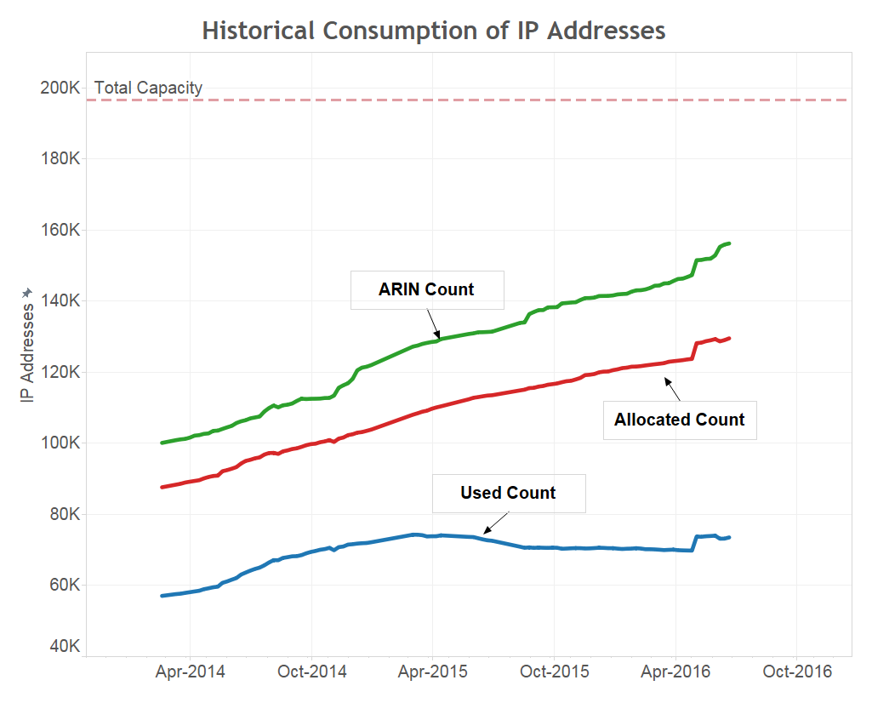

Figure 1. Historical consumption of Public IP addresses, Feb 2014 through June 2016.

### IP Subnets

Cerner tracks subnets within the VLAN database, maintained by the Network Community. Data is available for subnet allocations back to January 2010. The VLAN database is manually updated, and as a result there exist data quality issues with the VLAN dataset (duplicates and missing values.) A chart of the growth of public subnets has been generated, and this historical data is shown in Figure 2.

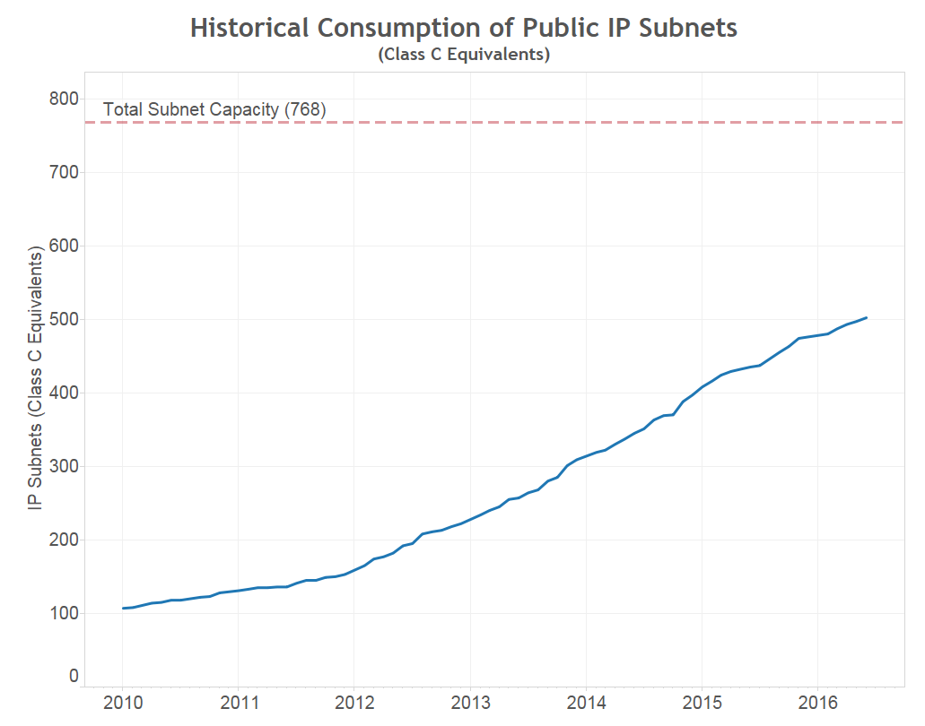

Figure 2. Historical consumption of IP Subnets

## When Will Cerner Run Out of IP Capacity? – Forecasts

### IP Addresses

One way of calculating the run-out date is to use a trending model. If we know the current capacity and how fast we have been consuming it, we can determine when we reach a run-out date (or a "reach 80%" date):

1. Current IP capacity (addresses, subnets)  
2. Historical Consumption rate (addresses, subnets)

This model assumes future growth will follow historic growth. To be more realistic, we need to consider “what-if” scenarios, such as unanticipated projects, the gain (or loss) of large clients, etc. Several of these scenarios (Windows OS Upgrade, Citrix Virtualization) were approximated in the current model, and we are waiting for BMC Capacity Optimization to be fully implemented before we can run true “what-if” models.

Figure 3 shows the projections of IP consumption based on historical trends. Linear models are used for the three counting methods used in this report.

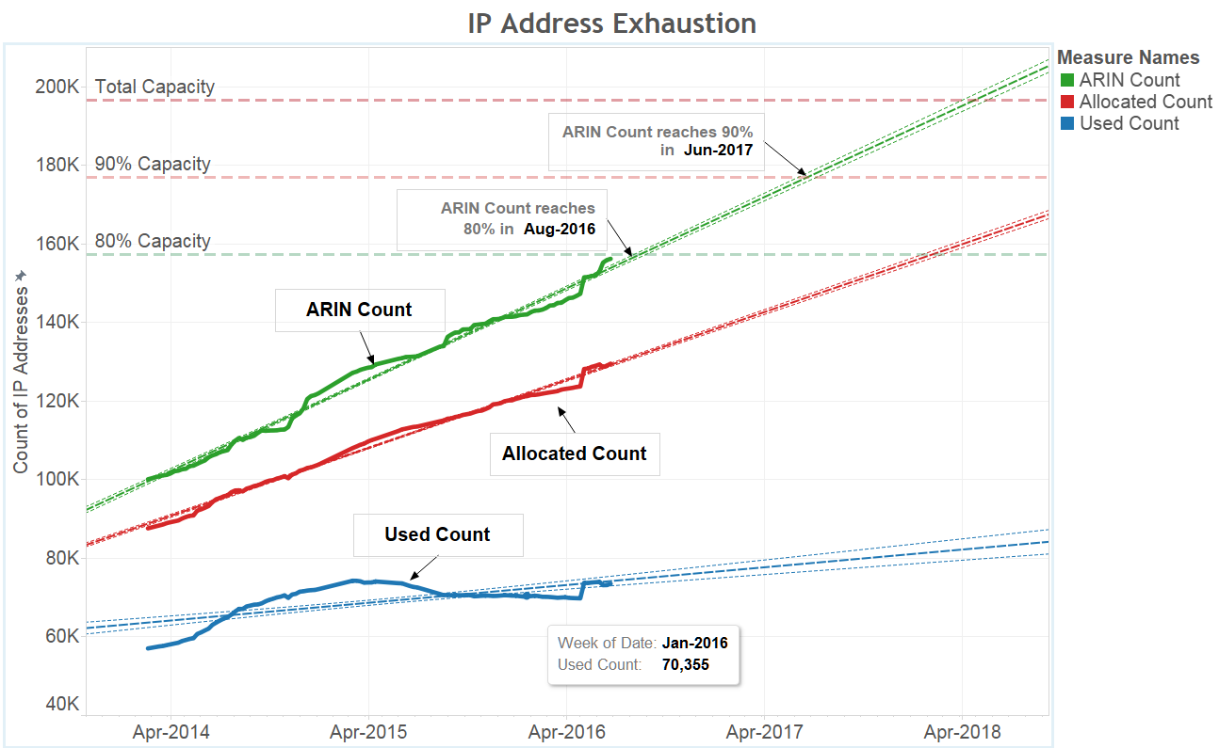

Figure 3. Projections of future IP Address Consumption

Run-out dates, taken from a linear forecast, is shown in Table 3.

|  |  |  |
| --- | --- | --- |
| IP Capacity and Consumption | Addresses  Allocated | Addresses  ARINCount |
| How much capacity is available? | 66,000 | 40,000 |
| How much by %? | 34% | 20% |
| How fast are we consuming capacity? | 1500 / month | 2000 / month |
| When will we run out? | April 2020 | March 2018 |
| When will we reach 90%? | March 2019 | May 2017 |
| When will we reach 80%? | Feb 2018 | July 2016 |

Table 5. Run-out dates for various IP address capacity statuses.

### IP Subnets

The VLAN database contains data on historical subnet creation – Data shown in Figure 4 goes back to January 2012. Consumption is modeled using a robust linear model.

It is unfortunate that the IP resource we are most concerned about has the poorest data quality. The Cap Mgmt team has a project scheduled for the summer of 2016 to clean up and standardize the subnet naming conventions used in Bluecat Proteus. It is hoped that this project will allow us to have much better subnet data.

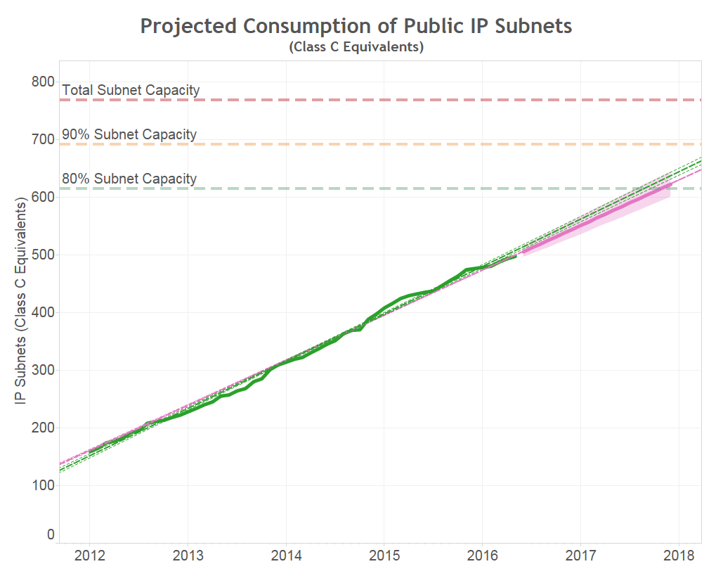 Figure 4. Forecasts of future IP Subnet Consumption

|  |  |
| --- | --- |
| IP Capacity and Consumption | Subnets  Used |
| How much IP subnet capacity is available? | 270 |
| How fast are we consuming IP subnet capacity? | 7 / month |
| When will we run out? | August 2019 |
| When will we reach 90%? | September 2018 |

Table 6. Run-out dates based on projected IP Subnet consumption rates.

N.B. The data for IP subnets is incomplete. It is important to improve the completeness and accuracy of the VLAN database.

# Summary

This report contains IP capacity data for various status of Public IP addresses. It covers the range of addresses from “used” (assigned to a deployed host) to “allocated” (provisioned in Proteus as either used or reserved) to “ARIN counting” (which considers any subnet allocated to a client to be completely full, even if it isn’t.)

Table 5 summarizes the state of IP Address capacity for Cerner’s public IP resources. Cerner Health Services (CHS) IP capacity is listed separately, as described in the report. Subnet data (VLAN database) is considered invalid and not included at all.

|  |  |  |  |  |
| --- | --- | --- | --- | --- |
| IP Capacity and  Consumption | CWx/CES  Used[5] | CWx/CES  Allocated[6] | CWx/CES  ARIN Counting[7] | CHS  Allocated |
| IP Capacity | 196,000 | 196,000 | 196,000 | 32,000 |
| IP Capacity Consumed | 73,500 | 130,000 | 156,000 | 25,500 |
| IP Capacity Available | 123,000 | 66,000 | 40,000 | 6,500 |
| How much has been consumed? | 38% | 66% | 80% | 80% |
| How much capacity is available? | 62% | 34% | 20% | 20% |
| How fast are we consuming capacity? | 400 /  month | 1500 /  month | 2000 /  month | 20 /  month |
| This will last how many months? | 310 | 45 | 20 | 326 |
| When will we run out? | - | April 2020 | March 2018 | - |
| When will we reach 90%? | - | March 2019 | May 2017 | - |
| When will we reach 80% | - | Feb 2018 | July 2016 | - |

Table 7. IP Capacity Summary

Using the ARIN counting method we are close to using 80% of our IP address resources, and have already received approval to proceed with a purchase of IP addresses from a 3rd party vendor.

Leadership has decided that buying more public IP addresses is the most cost-effective way to proceed with our current shortage, at a cost of $500,000. But soon, there will be no more public IPv4 addresses to be had. Based on historical trends, Cerner will be short of IP subnets again within 3 years of acquiring our 4th class B range (Q3-2019.). Other options are urgently needed to be evaluated and implemented.

1. Move current front-end hosts from using public IP addresses to using private IP addresses.
2. Assign private IP addresses to new builds that are not required to have a public IP address.
3. Consolidate and re-subnet any large subnet that is mostly unused, into smaller subnets that can be used more efficiently.

The option of using IPv6 addresses, which would solve the IP address scarcity problem for a long time, is being worked on, but it still a long way off (5 – 8 years.)

Cerner needs to improve its IP Address Management solution. The current tools, Bluecat Proteus and the VLAN database need to be augmented by a true IPAM solution.

Data quality is even more important. Unless we have accurate methods to determine capacity and consumption rates, the data is suspect, and the conclusions will not be correct.

# APPENDICES

## APPENDIX 1 - Why only Bluecat Proteus?

While Anthony Norell and team are developing the IP Data Warehouse (combining Bluecat, Remedy, and DNS data) I am using only Bluecat Proteus to quantify a "run-out" date.

Our IP Address Management tools are severely lacking, and the data is suspect. Hence the need for an IPDW. But despite all its warts, I'm using only Bluecat Proteus for several reasons

* Using only one dataset may introduce bias, but it is consistent bias over time. It is probably the best data source for determining consumption rate of IP capacity
* Bluecat is a provisioning tool, which means it includes data for most probable future IP (address and subnet) use. Remedy and DNS (and ADDM and ping sweep) will only have currently used (static, gateway, ...) addresses. And according to these tools (and Bluecat) we are using less than 40% of our public IP address capacity. Bluecat shows us what addresses and subnets are reserved for future use, whether clients, corporate resources, infra resources, projects (PVLAN, citrix virt, windows OS upgrades, ...). There are over 50,000 IP addresses in a "reserved" state that need to be considered when determining a run-out date.
* We will run out of subnets before we run out of IP addresses. But we really don't have good subnet data. The VLAN database is woefully incomplete. We have started a Bluecat Proteus cleanup project to be completed this summer that will allow Proteus to have reliable and accurate subnet data – at least for the public subnets.

## APPENDIX 2 - Data Wrangling Bluecat Proteus IP data

As I've said before, my "calculations" need to be validated by SMEs. They are not really calculations; they are really just judgement calls. If it were only calculations I could script it. Final utilization may go up or down several percentage points.

1. We have two Bluecat Proteus environments, one for CWx and one for CES. By combining the two we are over-counting by about 64,000 IP addresses. We have 196,608 public IP addresses and Bluecat shows 260,628. There are almost 300 subnet overlaps that need to be reconciled. Some are obvious but some are not. I may have mis-judged.

2. Subnets need to be classified as a "client" subnet or "not a client" subnet in order to perform ARIN Counting. Again, some are obvious but others are not, and again, I may have mis-classified.

All my data is contained in the spreadsheet in APPENDIX 4.  
There are several worksheets:

1. Original Data

This is the data from a Bluecat data export, for the three public class B ranges from the two Bluecat environments.  
Usage (Bluecat term) is given as percentages of static, reserved, gateway or free.

2. Tidy original data

Here the data is tidy'd up a bit. "Subnet mask" determines "subnet usable", and static, reserved, gateway, and free have their own columns.

3. Full list, dups marked.

Here the duplicate subnets are marked in color. There are 818 rows (subnets) that are colored.  
This data set shows we have 260,628 available IP addresses. Should only be 196,608.

4. Full list, dups to be removed.

This worksheet shows the subnets (in strikethrough font) I decided need to be removed from the combined data set.  
I marked 59 CWx subnets and 238 CES subnets for removal.

5. Full list, dups removed

This is the cleaned list of public IP subnets with duplicates and overlaps removed.  
This list shows 194,916 usable IP addresses, which is closer to he number of public IP addresses in our 3 public address ranges.

6. Final list with ARIN Counts

This worksheet adds a column of "client-or-not", which is needed for an "ARIN count".

Once this data set is verified we can put it in a form ARIN needs.

## APPENDIX 3 - ARIN Counting

This appendix explains the need for “ARIN Counting” and how it is calculated.

Clients get subnets for their server resources, projects require subnets, other (devices) require subnets; [anything with an IP address needs a subnet.] Subnets for Cerner clients and projects typically contain 64, 128, or 254 IP addresses, although there are larger and smaller exceptions.

In a subnet created for a new client, servers are assigned to the IP addresses. By design, there are IP addresses that are unused, with the expectation that future client growth with require these IP addresses. It is difficult to anticipate the future needs of clients and projects, and while some subnets are highly utilized, many subnets have large numbers of unused IP addresses, that is, there is no server host assigned to them.

Once a subnet is allocated to a client/project, all the IP addresses in that subnet belong to that client/project.

These unused IP addresses in client subnets cannot easily be used by other clients. Re-subnetting is costly in time and resources, is risky, and involves client downtime.

For this reason, we are currently only using 37% of our public IP addresses. Yet our ARIN count is at 80% and from the network architects point of view we have less than 2% of our IP resources available to create new IP subnets[8].

ARIN (the American Registry of Internet Numbers), the agency in charge of (giving out) public IP addresses, requires that we are at 80% utilization of our IP capacity before we can (petition) for more IP addresses. Fortunately, they let us count a client subnet as 100% utilized even if only a few IP addresses in that client subnet are (actually) used. We reached 80% (ARIN Counting) at the end of June 2016 and have been pre-approved to purchase a class B subnet range with 65,536 IP addresses.

## APPENDIX 4 – Bluecat Proteus Data – Merged CWx and CES

See the following link to access the Excel workbook described in Appendix B, with the following worksheets: [Merged Bluecat Proteus Data](https://connect.ucern.com/docs/DOC-528499)

1. Original Data

2. Tidy original data

3. Full list, duplicates marked in color

4. Full list, duplicates to be removed, indicated in strike-through font

5. Full list, duplicates removed

6. Full list with ARIN Counts

1. Used = Proteus statuses of Static + Gateway. (An address that would return a hostname in a ping sweep.)
2. Allocated = All IPs provisioned in Proteus as either Used (Static, Gateway), or Reserved.
3. ARINCount = Counting method ARIN uses to assess need for additional IP addresses. See report. Essentially counts all client subnets as completely used even if they are not.
4. On Jan 5, 2016, Bluecat Proteus was upgraded and renamed to Bluecat Address Manager (BAM). But BAM is still just a provisioning tool, as the reconciliation feature has been disabled. It is still known as Proteus in the trenches.
5. Used = Proteus statuses of Static + Gateway. (An address that would return a hostname in a ping sweep.)
6. Allocated = All IPs provisioned in Proteus as either Used (Static, Gateway), or Reserved.
7. ARINCount = Counting method ARIN uses to assess need for additional IP addresses. See report. Essentially counts all client subnets as completely used even if they are not.
8. Without a true IP Address Management tool, these numbers are somewhat uncertain. The point is, we will soon be out of subnets.